**ROCESS MANAGEMENT :**

***Ps:***

displays information about the processes associated with the current terminal session.

***Ps -a***:

List all processes except session leaders (instances where the process ID is the same as the session ID) and processes not associated with a terminal.

***Ps -e***:

Lists all processes on the entire system, offering a complete overview of running tasks and programs.

***Ps -d***:

Lists all processes except session leaders, providing a filtered view of processes running on the system.

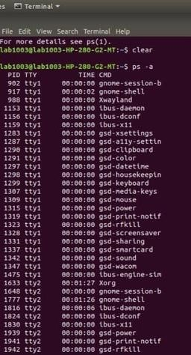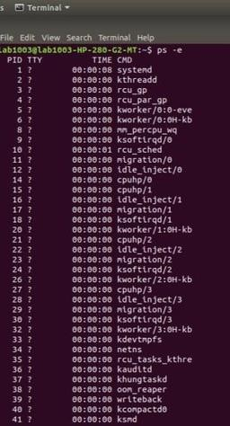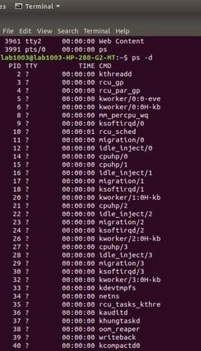

***Pstree***:

Pstree command in Unix that shows the running processes as a tree which is a more convenient way to display the processes hierarchy and makes the output more visually appealing.

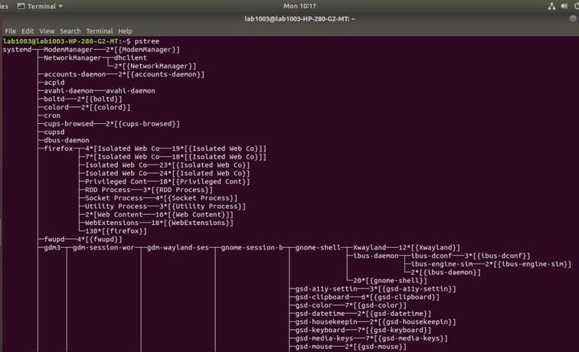

***Pstree -a:***

This command now displays command line options for some processes.

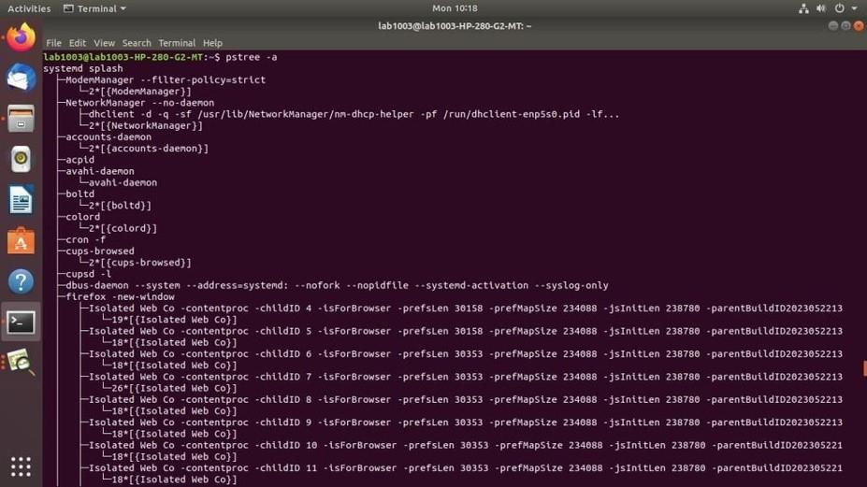

***Pstree -p***:

To display PIDs for each process name, we use “-p” option.

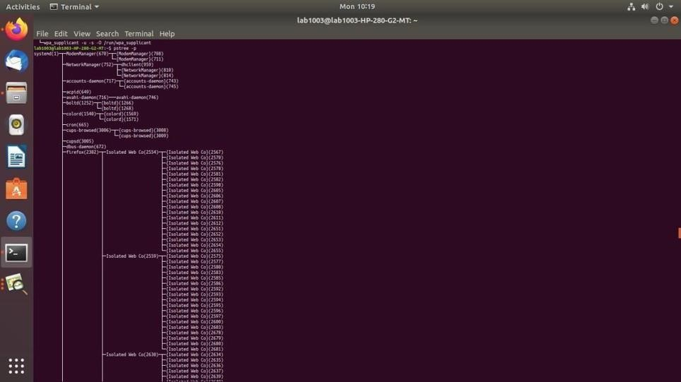

***Nice***:

nice command in Unix helps in execution of a program/process with modified scheduling priority

***nice -10 gnome-terminal***: To set the priority of a process ***nice --10 gnome-terminal***: To set the negative priority for a process

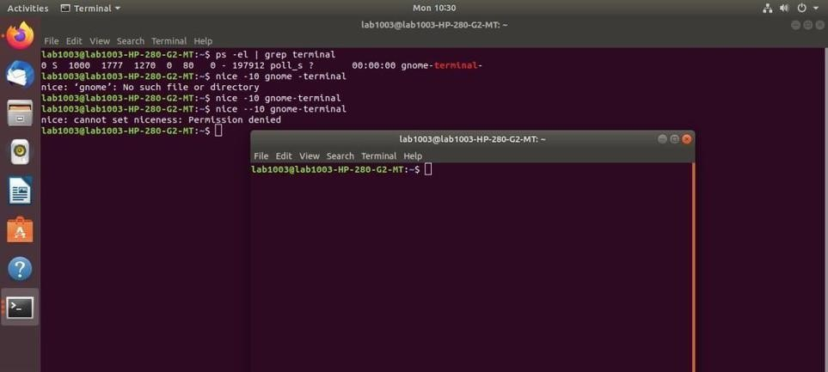

***Renice***:

the renice command allows you to change and modify the scheduling priority of an already running process.

***sudo renice -n 15 -p 1777 :***changing priority of the running process.

r***enice -n 10 -g 4***: To change the priority of all programs of a specific group. sudo renice -n 10 -u 2: To change the priority of all programs of a specific user.

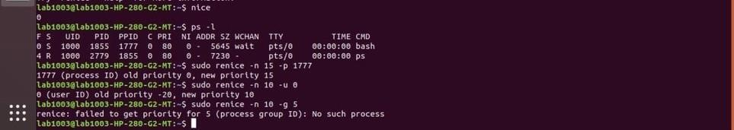

***Kill:***

Kill is a built-in command which is used to terminate processes manually. kill command sends a signal to a process that terminates the process.

***kill number PID:*** We can specify a signal using a number. For example, we have a PID `1212` and want to send a `SIGKILL` signal to kill this PID.

***kill -SIGTERM PID:***

We can also specify signal using SIG prefix.

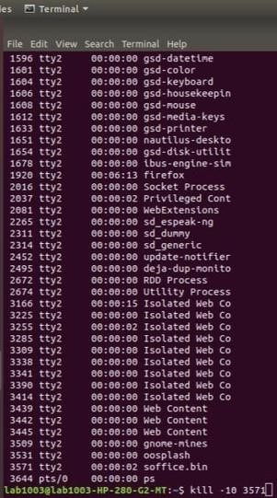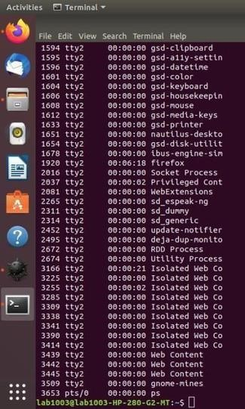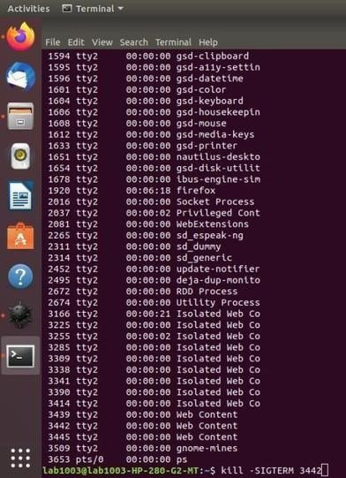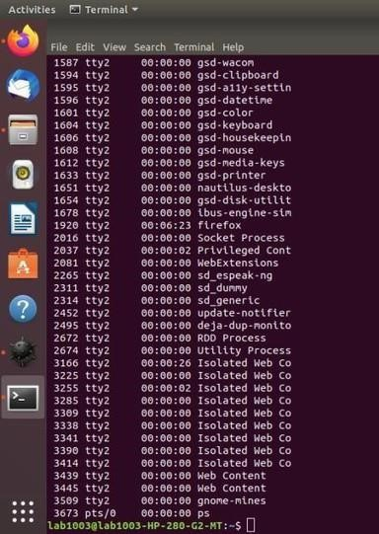

***Pkill:***

The pkill command uses name of the process instead of PID number. Signal can be send to a process either by typing full name or partial name.

***Pkill -n name:***

Kills the process name mentioned



***Xlsclients:***

This command will show the list of all open windows with the hostname.

***Xkill:***

xkill is a command-line utility that can kill the undesired windows on the user’s screen. Basically, xkill force the X server to close the connection to the client. This utility kills the programs without providing PID with a command.

For using xkill to kill the open window, just run the xkill command. Then your cursor will turn into an X sign.

Then right-click on the windows which you have to kill.

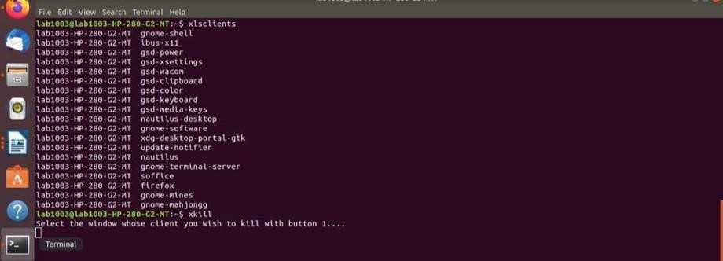

***Jobs:***

To list all your measures forked from the current shell use “jobs” command ***yes > /dev/null & :***

The command will begin the process yes and yield its standard output to/dev/null. The second line contains the accompanying data “[1]” ( work ID ) and “16017” the real PID

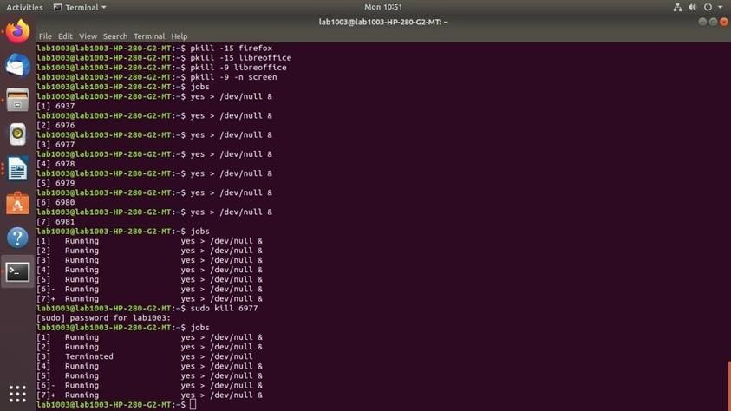

***killall name :*** Ending each cycle individually can end up being hard and repetitive work. We should see Whether we can get some assistance by utilizing killall order and process cycle name

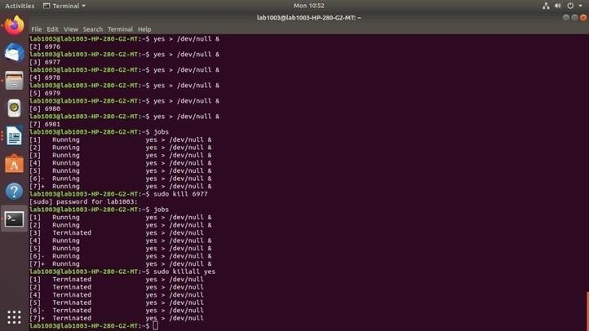

***Fg:*** fg command in unix used to put a background job in foreground.

***%n :*** Refer to job number n.

***%str*** : Refer to a job which was started by a command beginning with str.

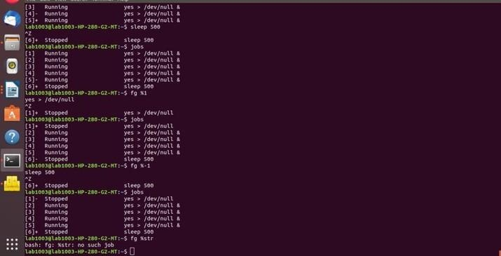

Bg: The 'bg' command is primarily used when you wish to run a job/process in the background after it has been stopped or paused.

%n : Refer to job number n.

%str : Refer to a job which was started by a command beginning with str.

Pgrep: The pgrep command is a tool that searches for processes based on their name and other attributes, and returns their PIDs.

Pgrep ssh: If there are running processes with names matching “ssh”, their PIDs will be displayed on the screen. If no matches are found, the output is empty. pgrep ssh -d' ': The option allows you to specify a different delimiter.

- pgre pgrep ssh -l: The option tells to show the process name along with its ID pgrep '^ssh$' -l: If you want to match only the processes which names are exactly as the search pattern, you would use this command.

-u pgre pgrep -u root: the option to tell to display processes being run by a given user

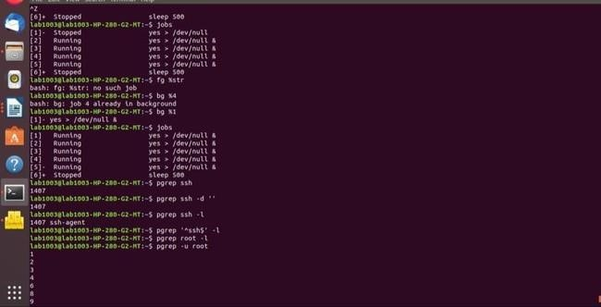

**MEMORY MANAGEMENT :**

Free: The free command is a Unix command that allows you to check for memory RAM on your system or to check the memory statics of the Unix operating system.

Free -g:It displays the amount of memory in gigabytes. Free -b: It displays the memory in bytes.

Free -h: It shows all output columns automatically scaled to shortest three digit unit and display the units also of print out.

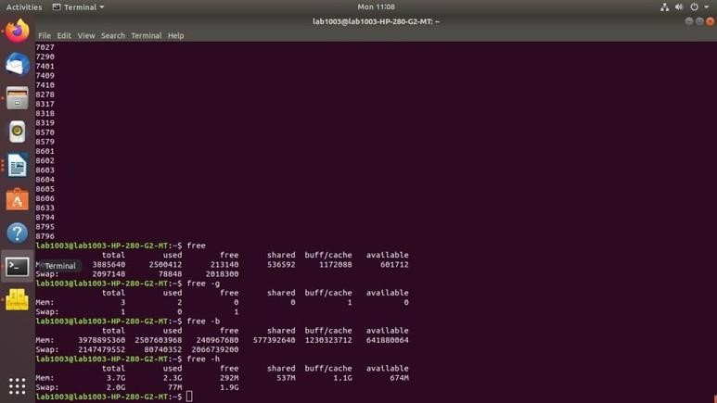

Proc: Proc file system (procfs) is a virtual file system created on the fly when the system boots and is dissolved at the time of system shutdown. ls -l /proc :This command will list all the files and directories under the `/proc` directory with detailed information like

permissions, ownership, size, and time of modifications. ls -ltr /proc/6311:gives information about the process with PID 6311.

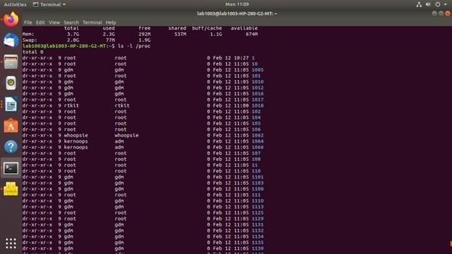

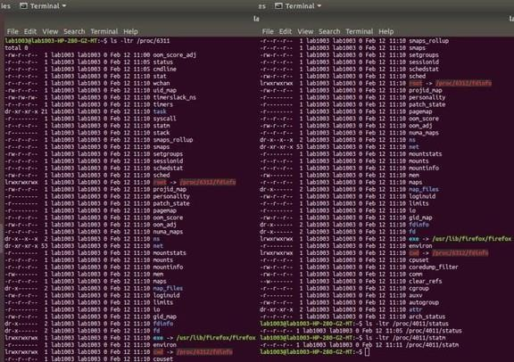

/status: To View The status of the process

/statm: To View The memory usage of the process

Meminfo: Displays the memory information.

cat/proc/meminfo: to determine how much memory the computer has.

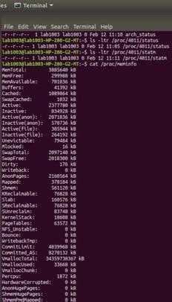

Top: The top command is used to show the active Unix processes. It provides a dynamic real-time view of the running system.

Top -n 10: Top output keep refreshing until you press ‘q‘. Top command will automatically exit after 10 number of repetition.

Top -h: Shows top command syntax

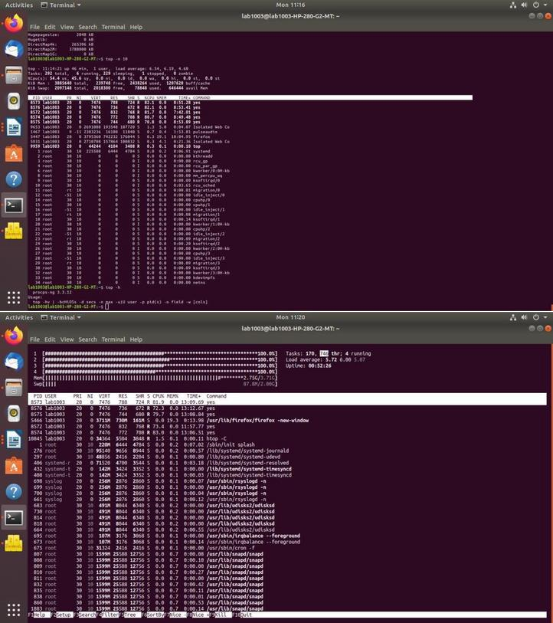

Htop: htop is a useful command-line tool in the Unix environment to determine the cause of load by each process.

Htop -h: Used to display the help message and exit. Htop -c: Start htop in monochrome mode.

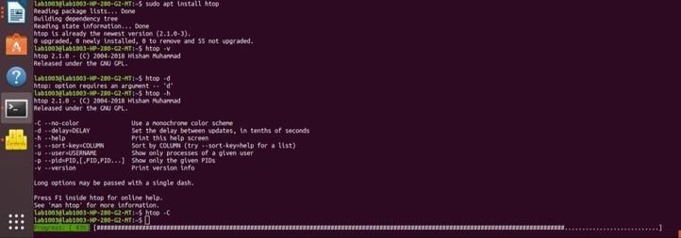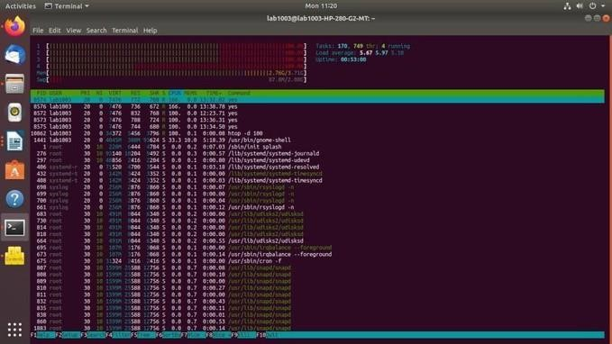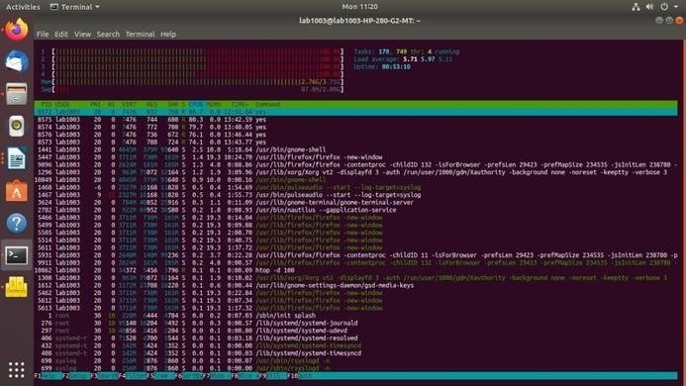

Df: The df command displays information about total space and available space on a file system. Df -h: Prints sizes in a human-readable format using power of 1024. Filesystem: The name of the mounted storage device (e.g., /dev/sda4). Size: The total size of the filesystem in bytes. Used: The amount of space currently occupied by data in bytes. Avail: The amount of free space available in bytes.

Use%: The percentage of the filesystem used.

Mounted on: The directory where the filesystem is mounted (e.g., /, /home).

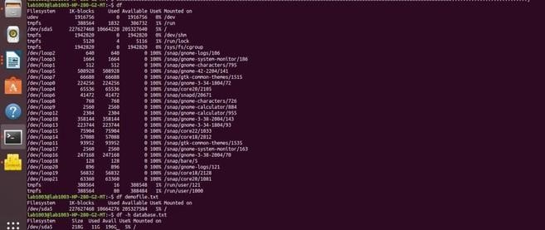

Du: The 'du' command in Unix is used to estimate file and directory space usage. Du -h: If we want to print sizes in human readable format(K, M, G), use -h option

Du -a: Displays disk usage information for all files and directories, including hidden ones.

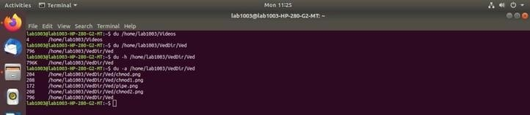

Vmstat: vmstat command in Unix is a performance monitoring commandof the system as it gives the information about processes, memory, paging, block IO, disk, and CPU scheduling.

Vmstat -f: It displays the number of forks since boot. Each process is represented by one or more task, depending on thread usage.

Vmstat -a: It displays active and inactive memory of the system running. Vmstat -m: It displays the number of forks since boot. Each process is represented by one or more task, depending on thread usage. Vmstat -s: This command is used to display a table of various event counters and memory statistics.

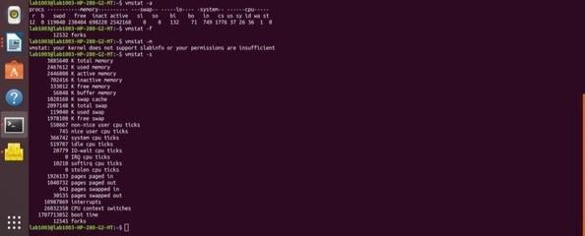

Pagesize: The pagesize command prints the size, in bytes, of a page of memory, as returned by the getpagesize subroutine

Pagesize -a: Prints all of the page size values (in bytes) supported on the system.

Pagesize -H:Shows only huge page size.

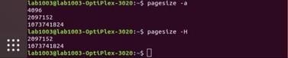

Sar: sar (System Activity Report) It can be used to monitor Unix system’s resources like CPU usage,

Memory utilization, I/O devices consumption etc. sar -V: Displays The current version. sar -u 2 5: To report CPU details a total of 5 times with the interval of 2 seconds.

sar -r 1 3 :To report about the amount of memory used, amount of memory free, available cache, available buffers total 3 times with the interval of 1 second. sar -F 2 5: To report about file systems mounted on the device total 5 times with the interval of 2 seconds. sar -q 2 5:To report run queue length, number of processes and load average

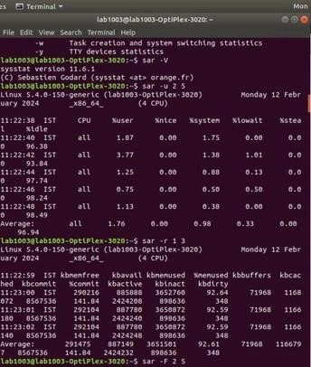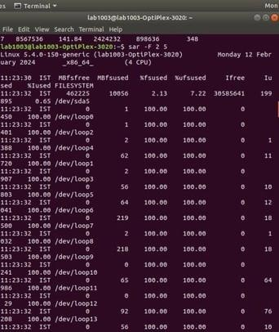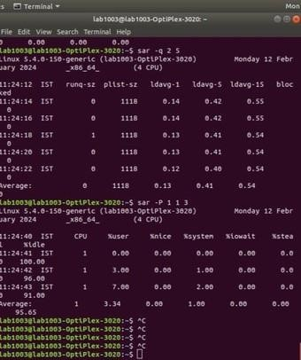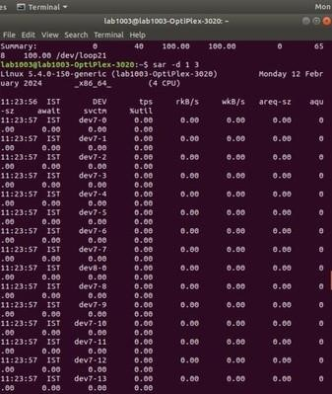

Dmicoded: dmidecode also referred as Desktop Management Interface table decoder, record data from DMI table and produce it in human readable format.

Sudo dmicoded | more: Running a simple dmidecode command to get hardware information. Sudo dmicoded -t processor: To get information about Processor. Sudo dmicoded -t bios: To get BIOS information.

